1. **Result:**

**Comparison of Different ML Algorithm**

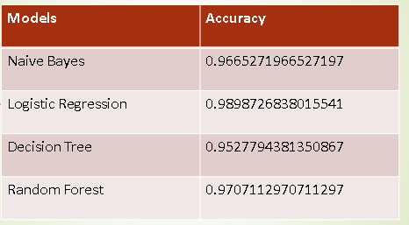

### Predict Class label for the unseen data i.e., Spam or Ham

Here we are predicting the SMS/MAIL from the dataset and classifying that weather it’s is HAM or SPAM .

